Story about Leaf
by Galang36

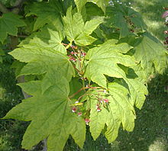
Leaf is a part of tree that colored green. Leaf has much function but it will be described on next paragraph on this story. Most tree have leaves include cactus, but cactus’ leaves are modified to spike to reduce evaporation.
Leaf will turn from green to brown if the leaf is old. Leaf’s color change procedure is like frying tempeh. From green to yellow then brown. Do you know, maple leaf turning to brown when autumn. Because it protecting its circulation
from the cold. And will grow again when spring season is
coming.
Maple Leaves
Leaf contains chlorophylls and stomata. Chlorophylls used for making sugar for tree’s food. And stomata used for breathing. And when chlorophylls cook food, that process also called photosynthesis.
The result from photosynthesis is oxygen and carbohydrate. We use oxygen for breathing and the carbohydrate for our food. That is why we must keep tree alive.

